**Jewel Management-(Developer)**

College Name: Nandha Arts and Science

College Code: bru4j

**Team ID:** NM2025TMID22975

**Team Members:**

**Team Leader Name**: THAMIZHAN P

Email: thamizhanet1126@gmail.com

**Team Member1:**  MOHANRAJ S

Email: massfree123456@gmail.com

**Team Member2**: YOGANATHAN P

Email: yoganathan.p123@gmail.com

**Team Member3:** VIGNESHWARI D

Email: dvigneshwariv@gmail.com

**Introduction:**

The Jewel Management CRM is a Salesforce-based solution developed to simplify and modernize the operations of jewel businesses. Traditional jewel management often faces challenges such as maintaining accurate inventory of precious metals and stones, handling customer data securely, and ensuring personalized service. This project aims to address these challenges by leveraging Salesforce’s robust CRM capabilities to create a centralized platform for sales, inventory, customer engagement, and business analytics.

**Purpose:**

The purpose of developing the Jewelry Management CRM is to provide a comprehensive, technology-driven solution for managing the unique needs of the jewelry industry. The system is designed to streamline daily business operations such as customer relationship management, sales tracking, inventory control, billing, and after-sales support, all within a single Salesforce platform.

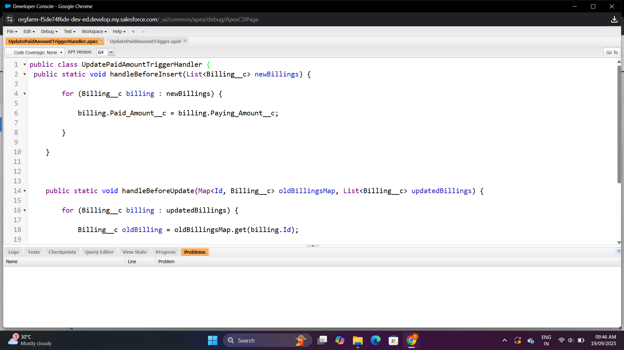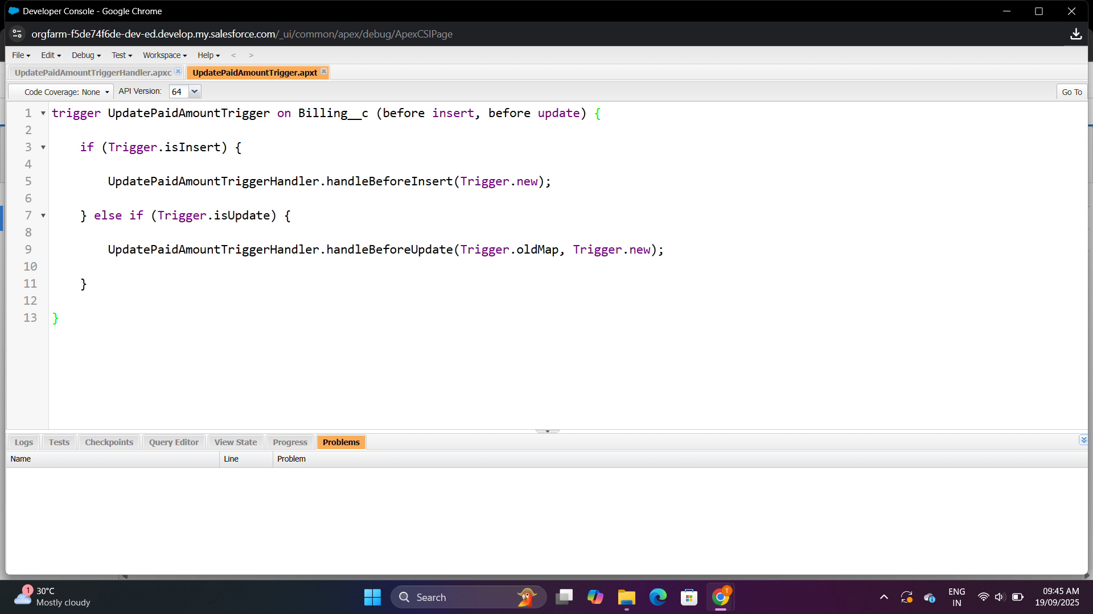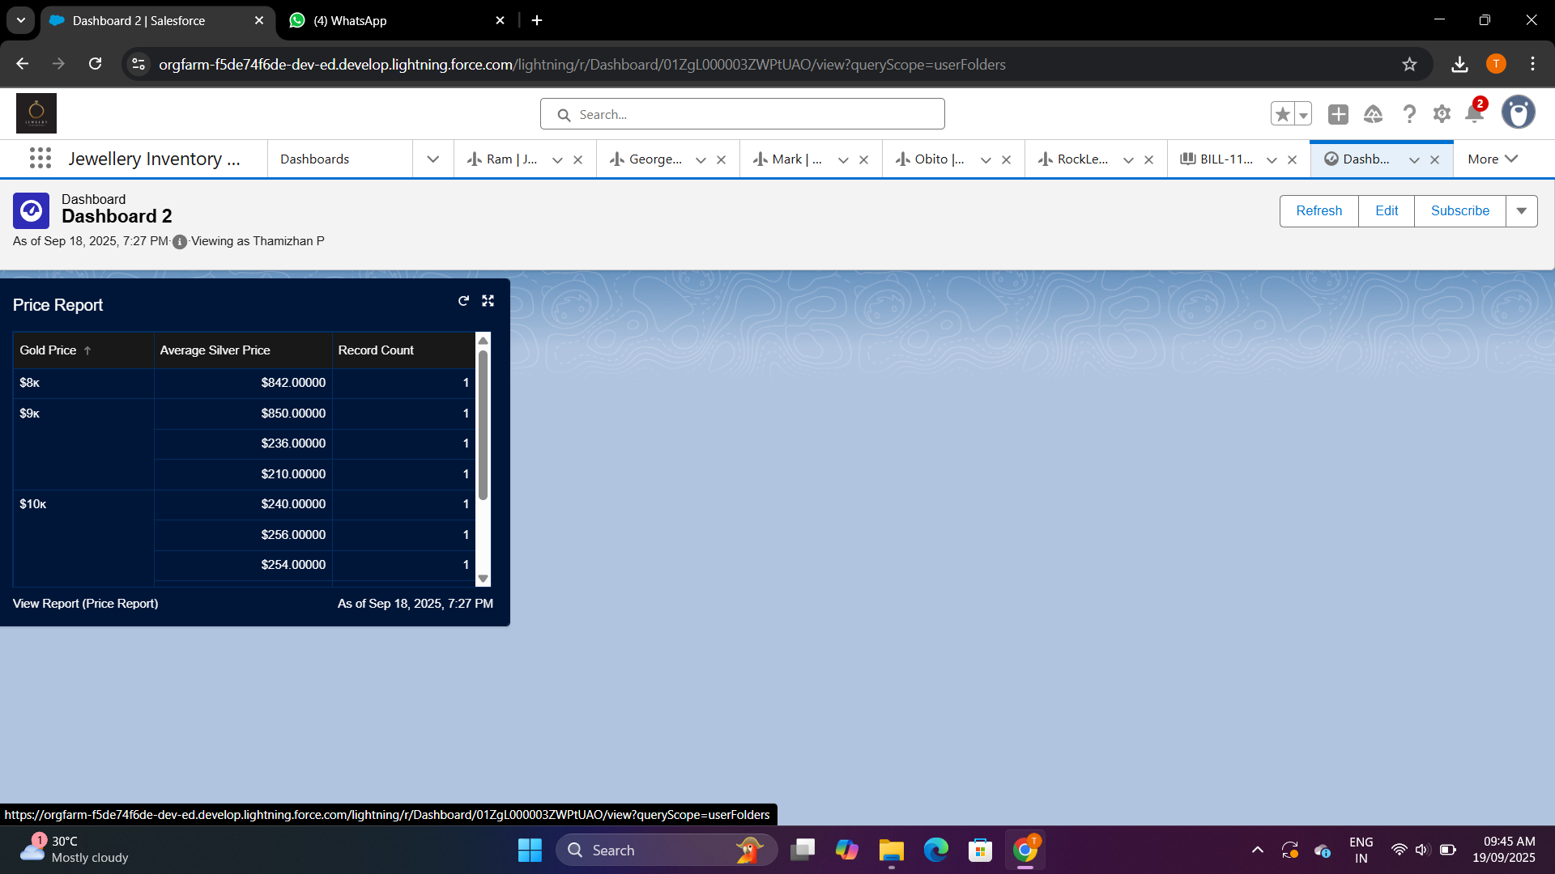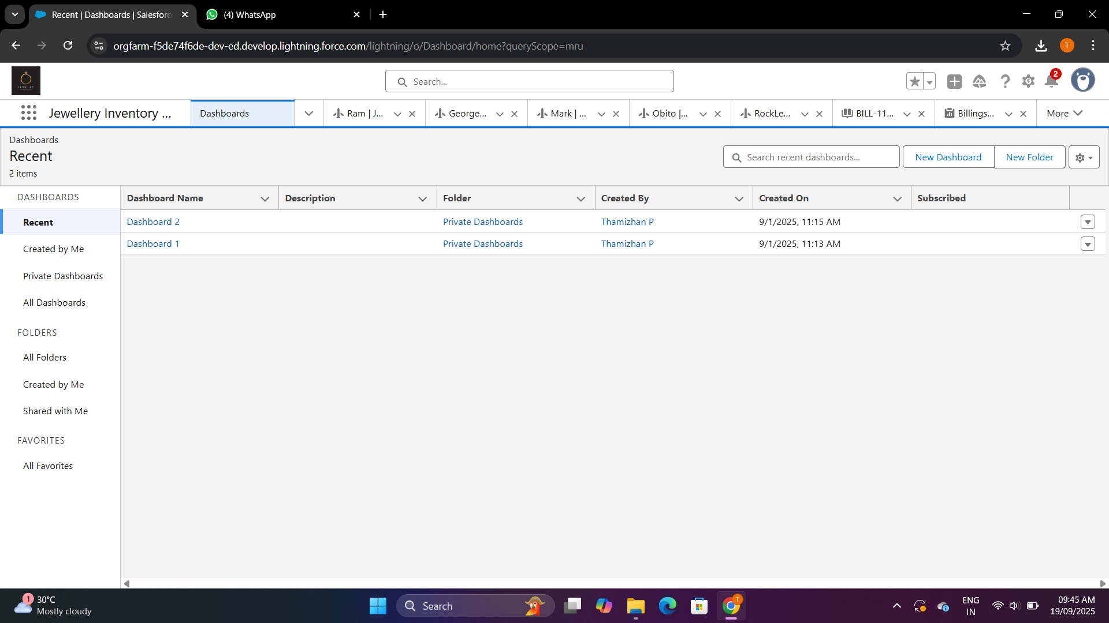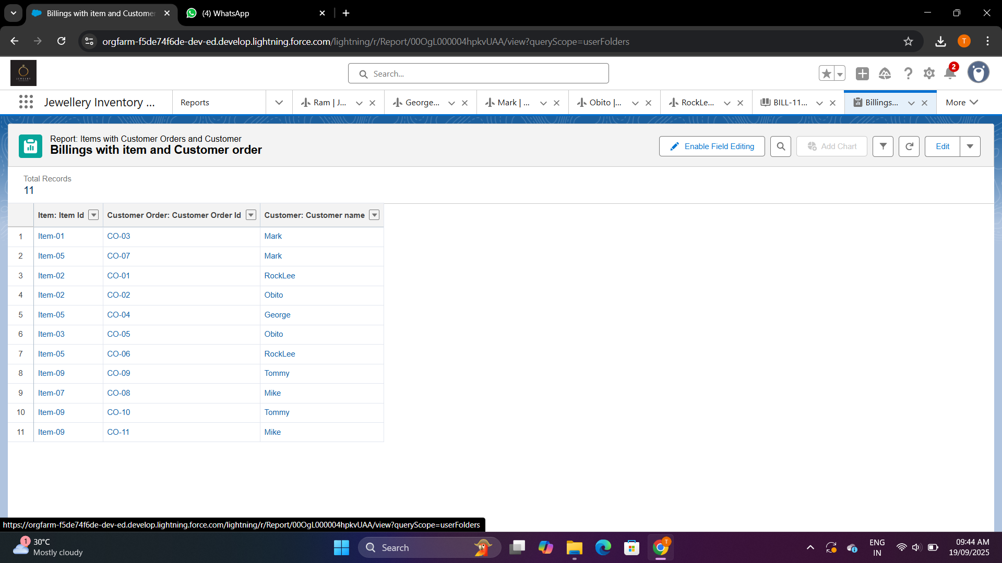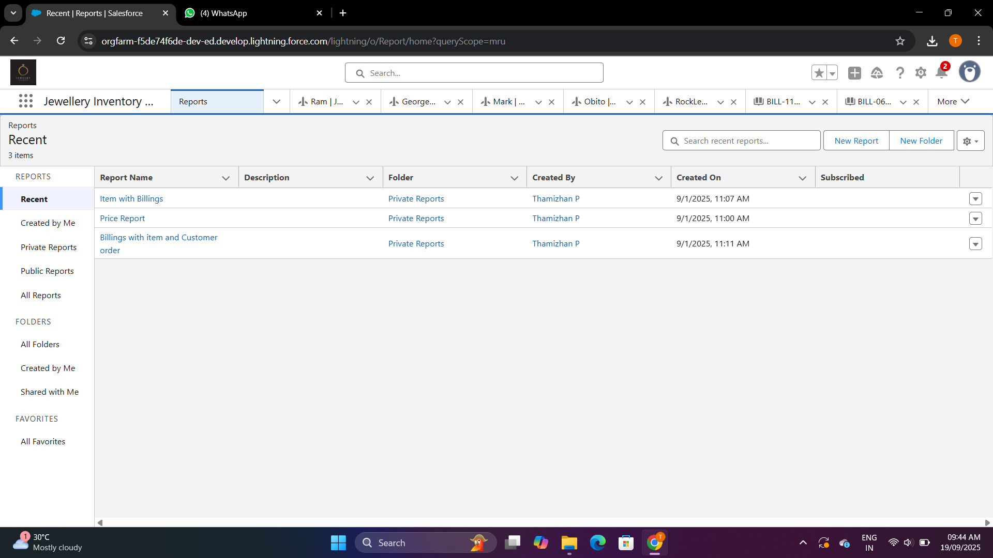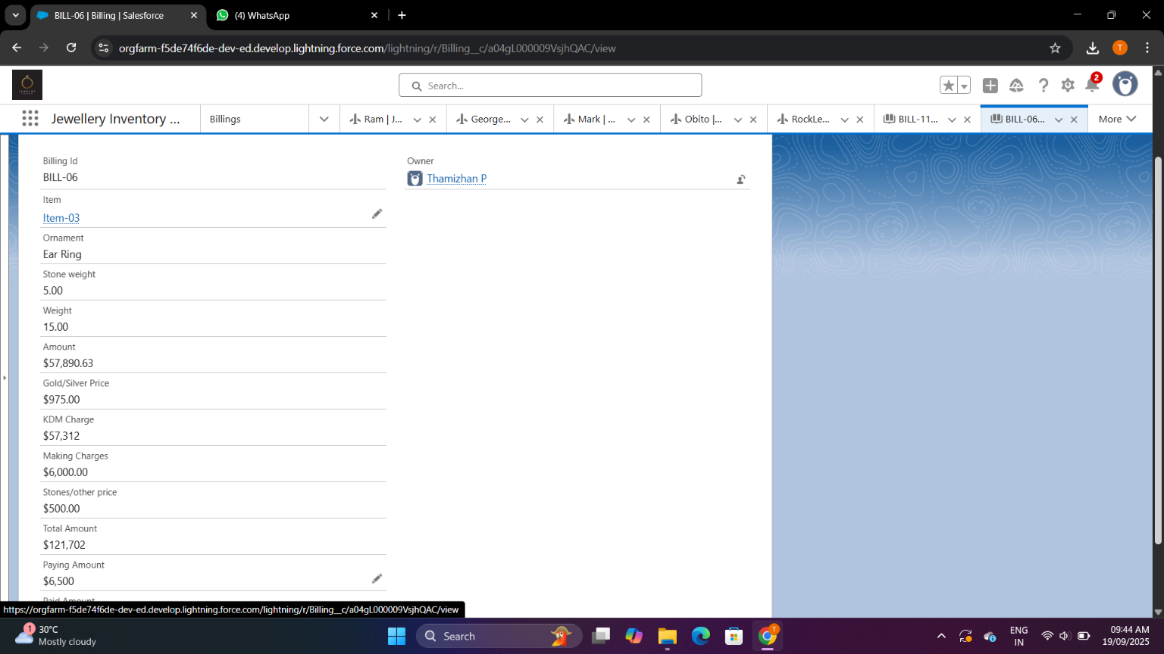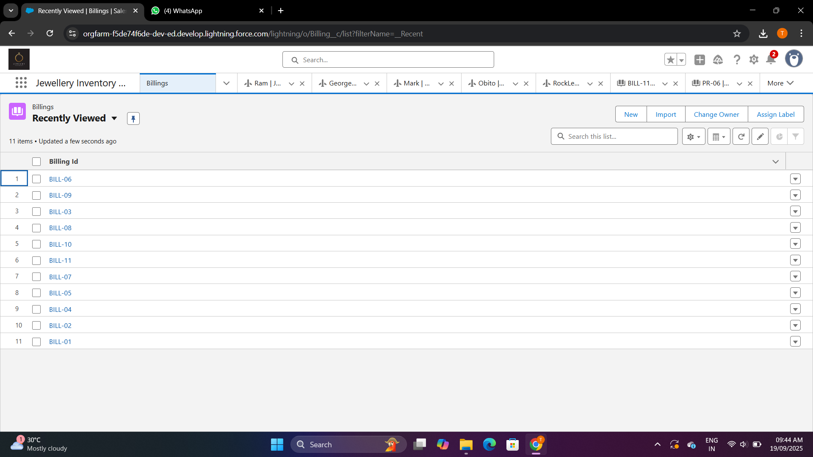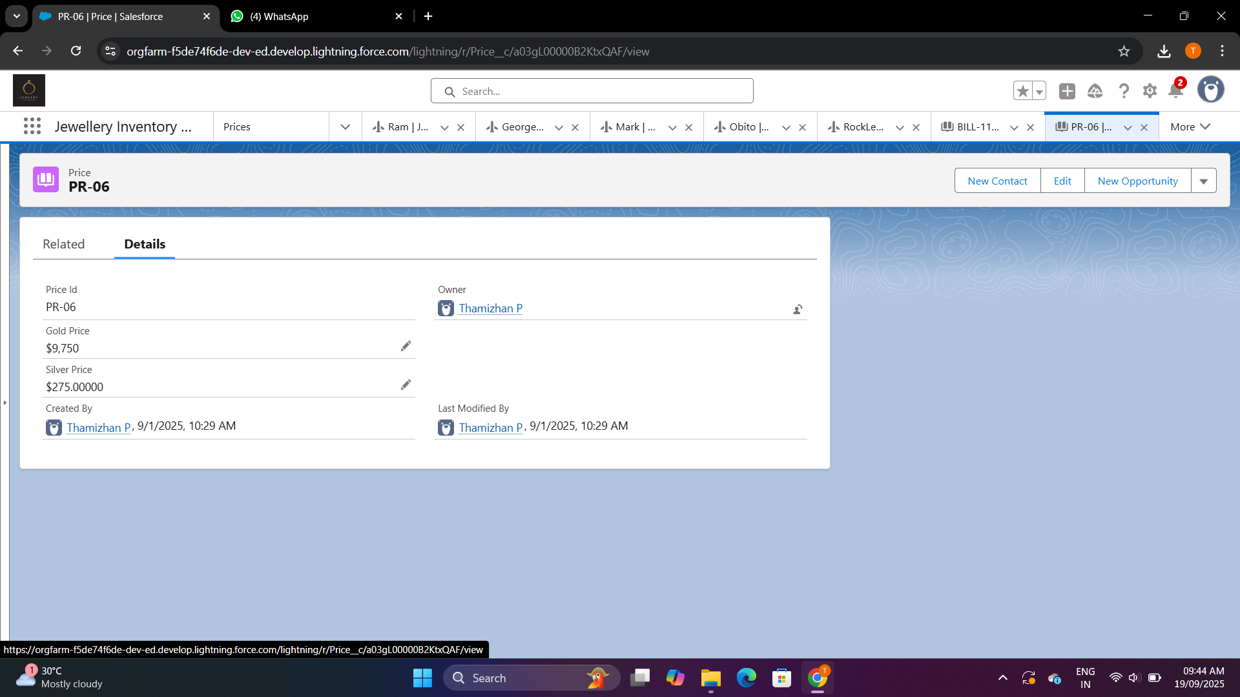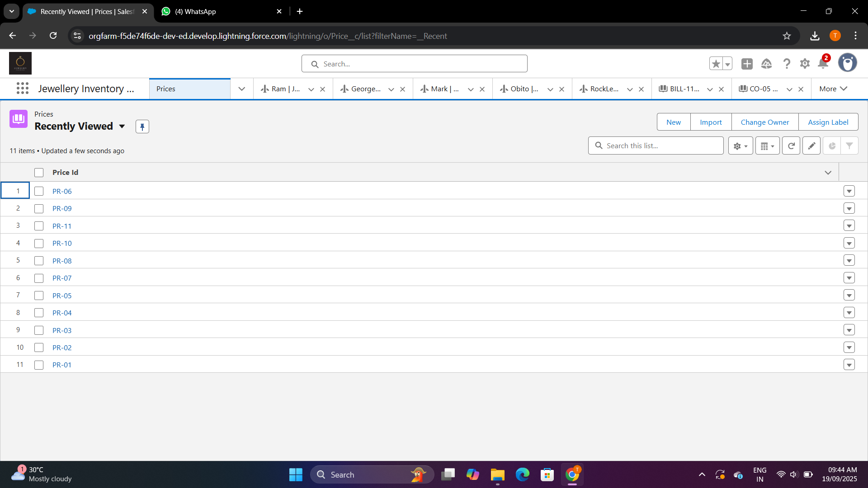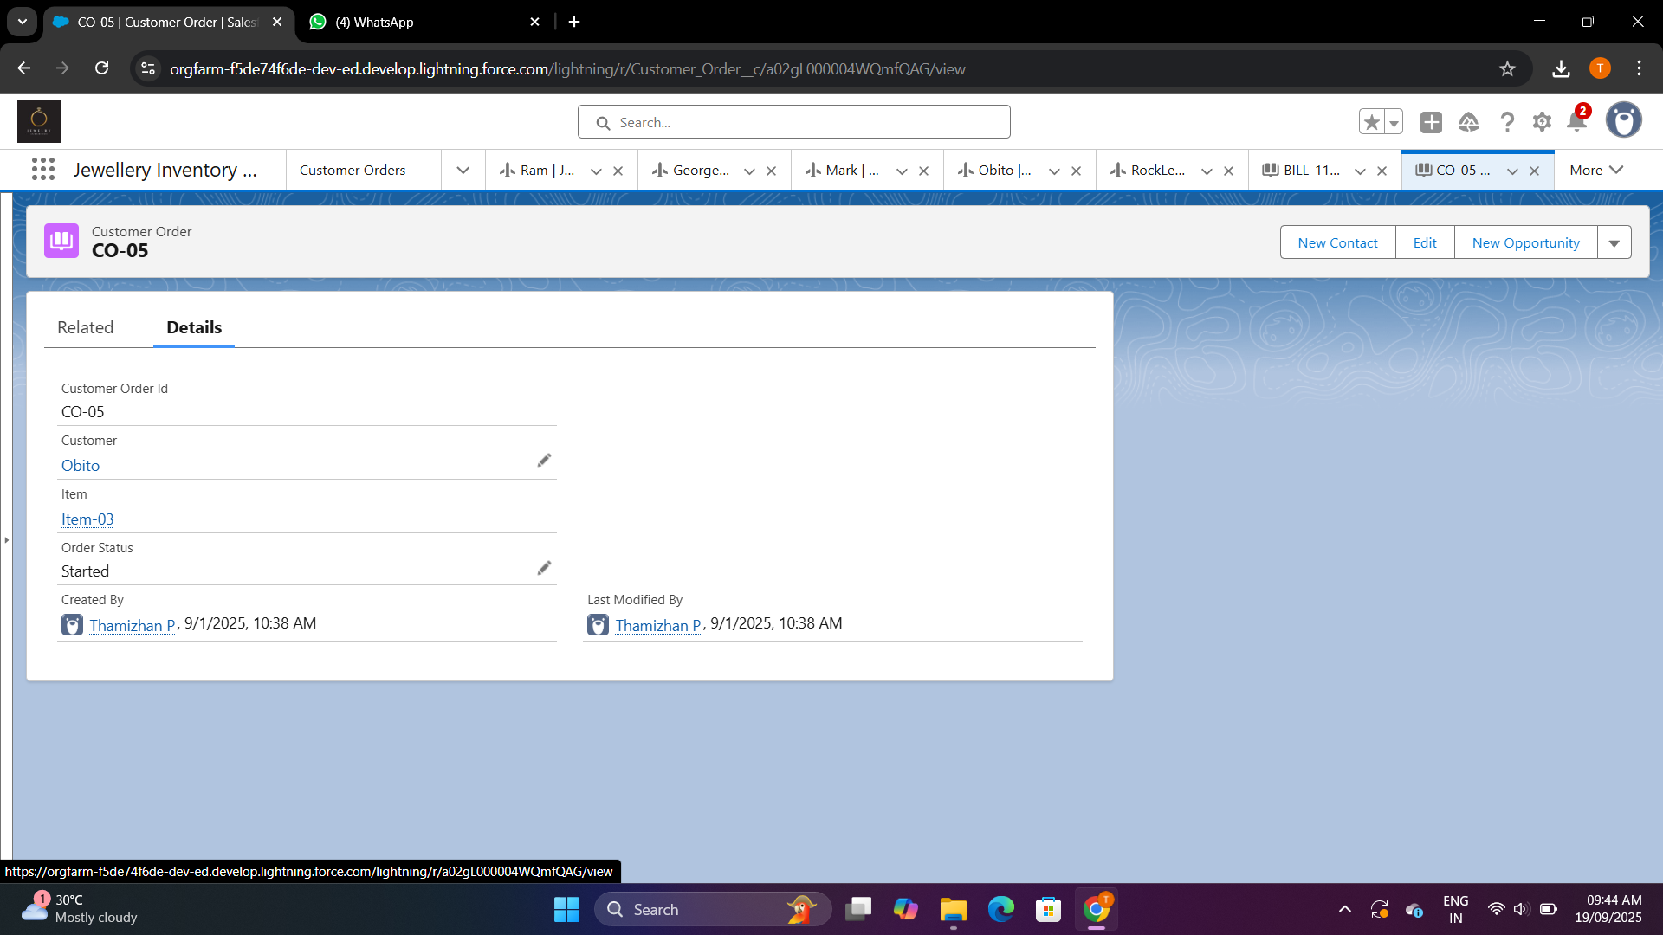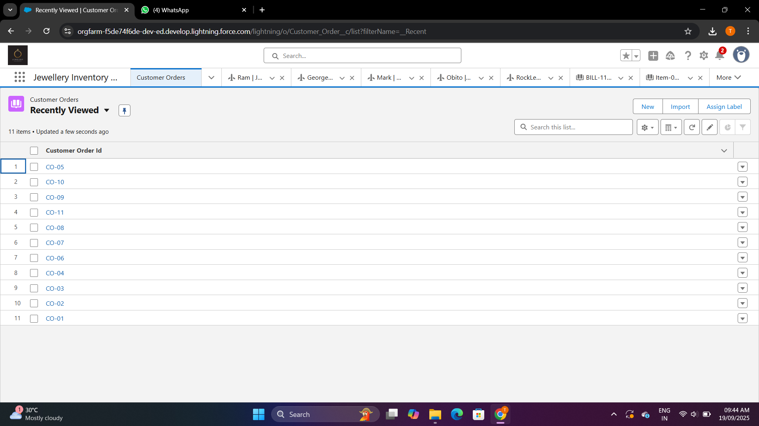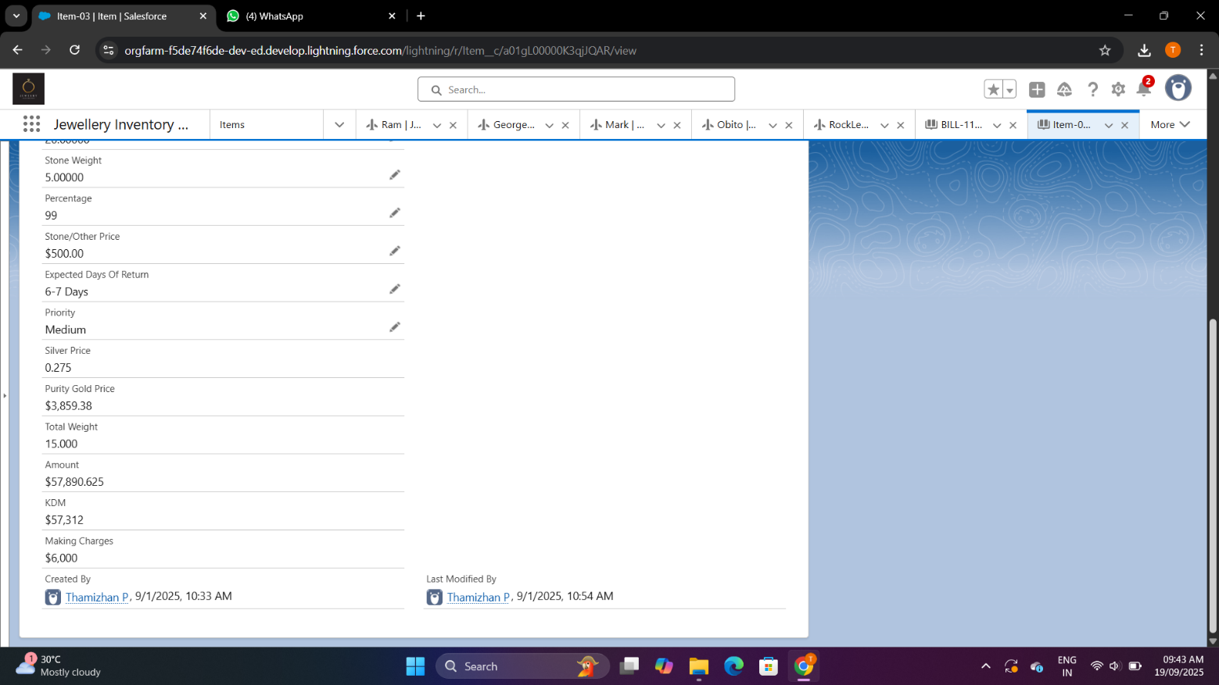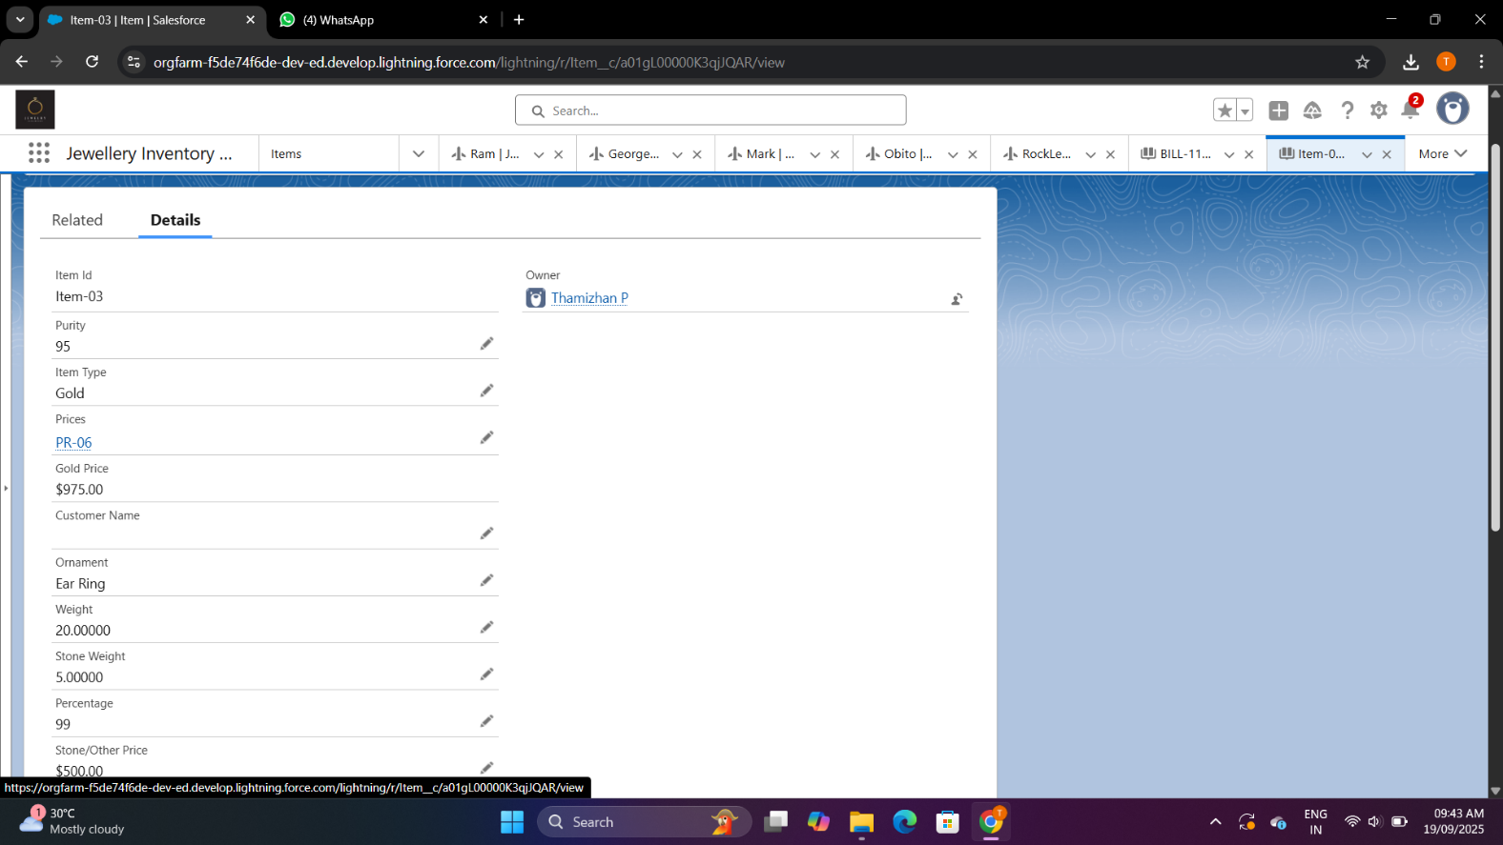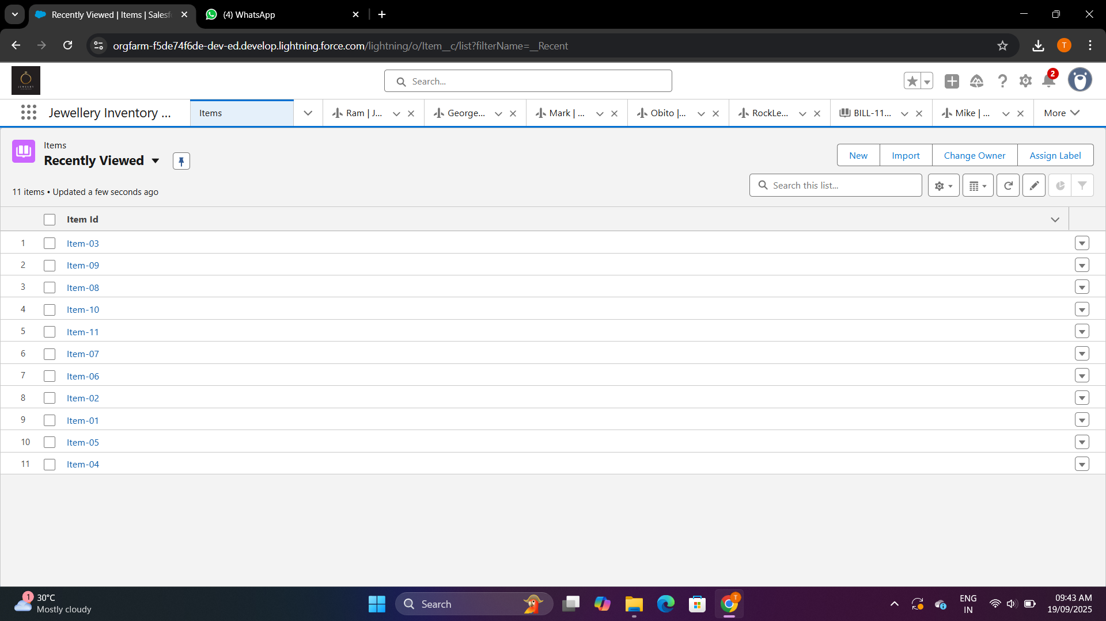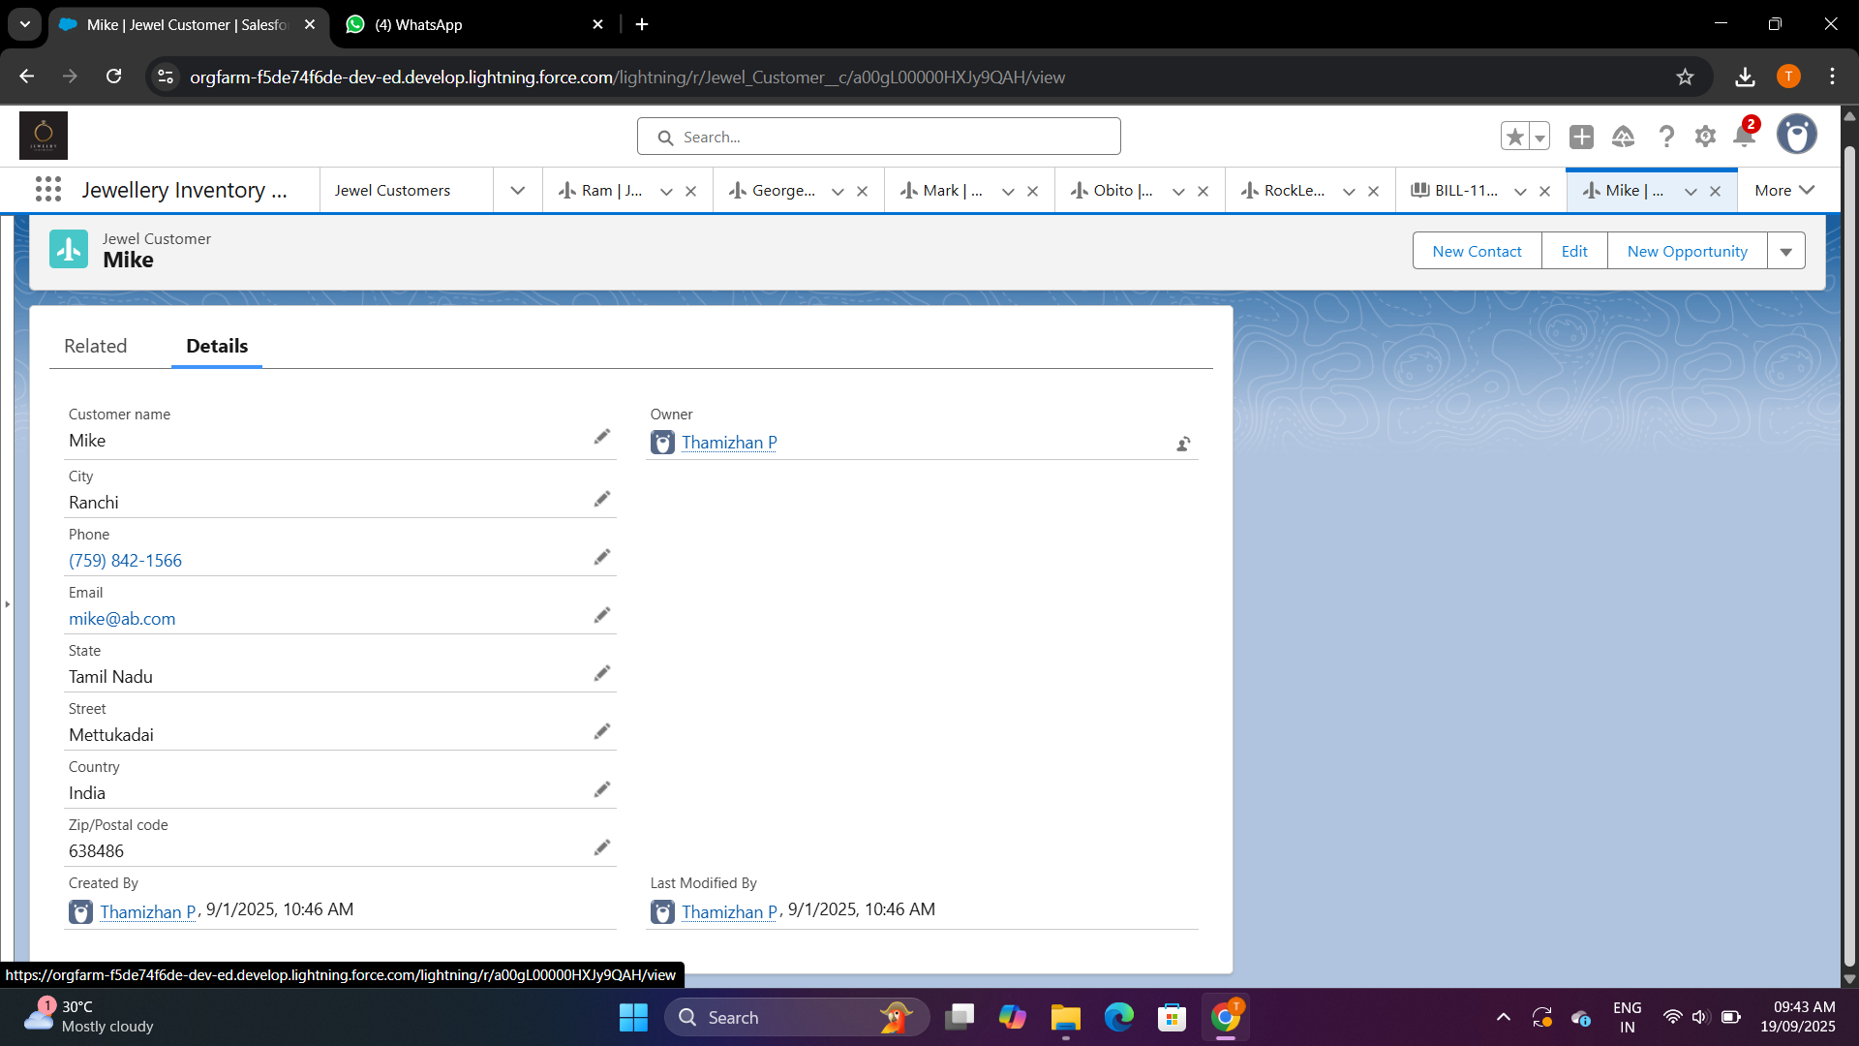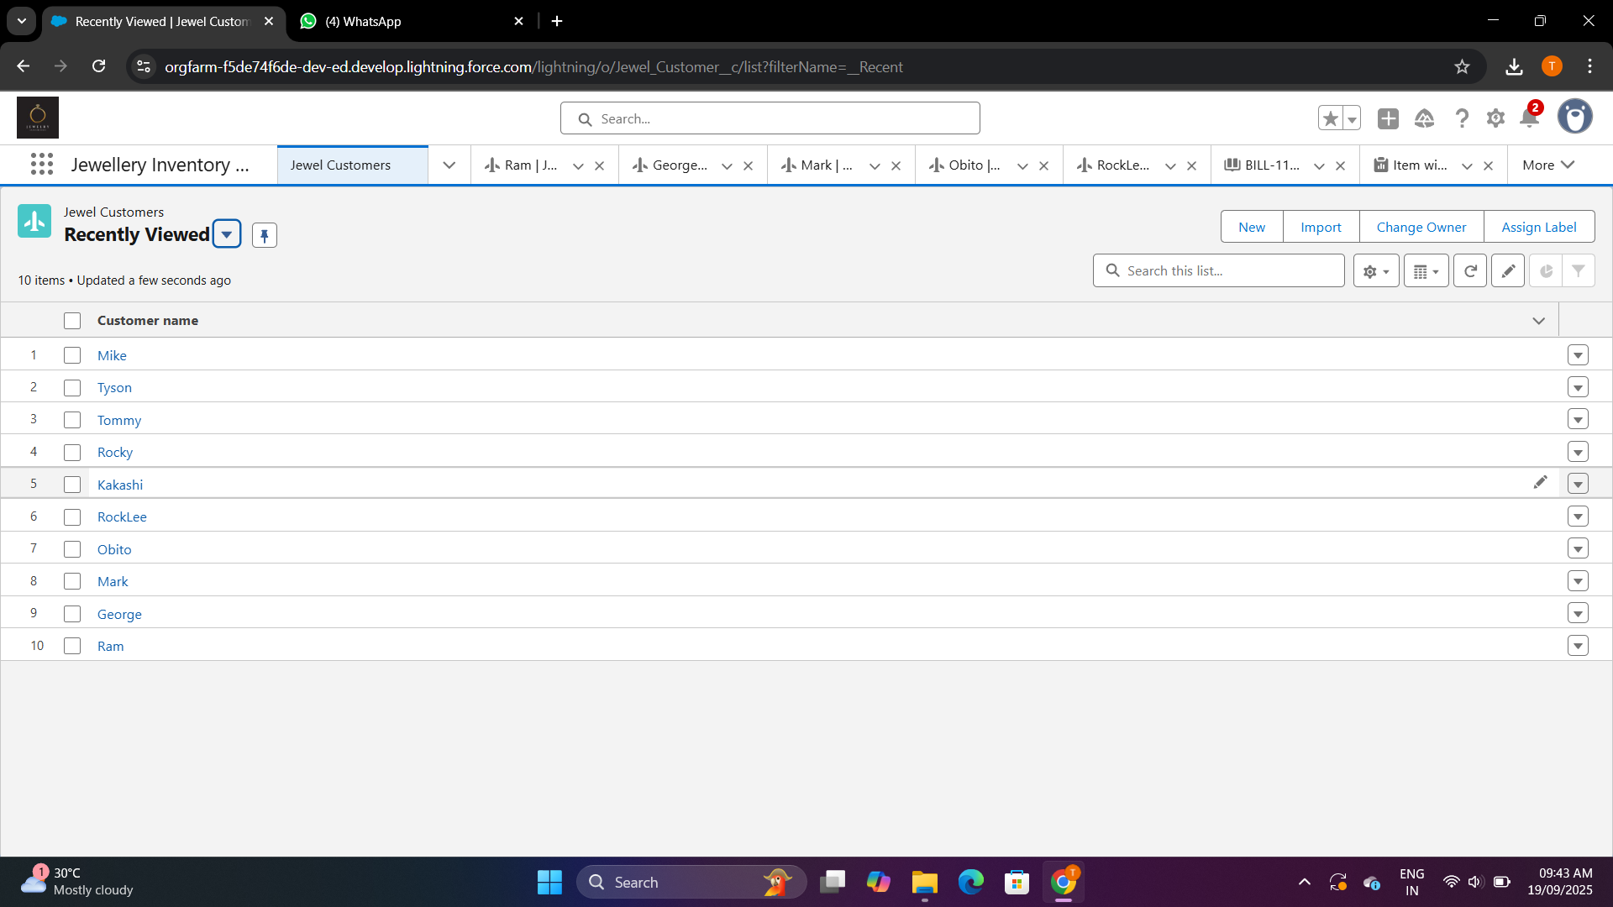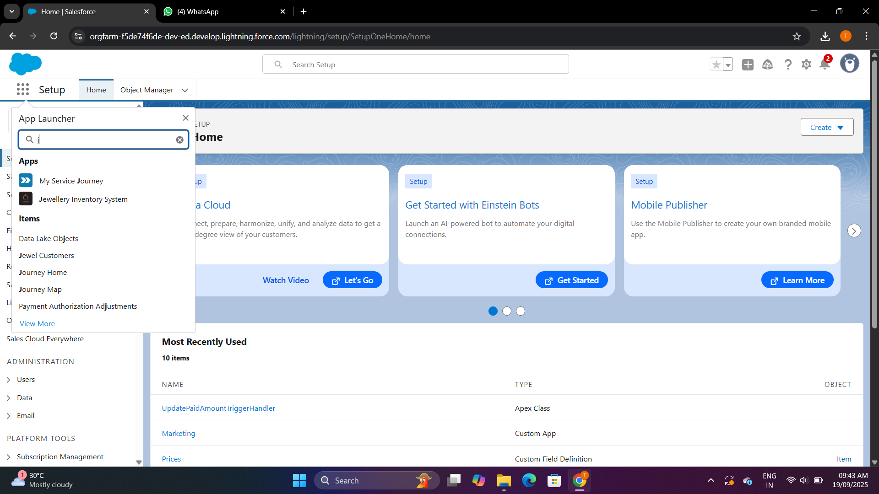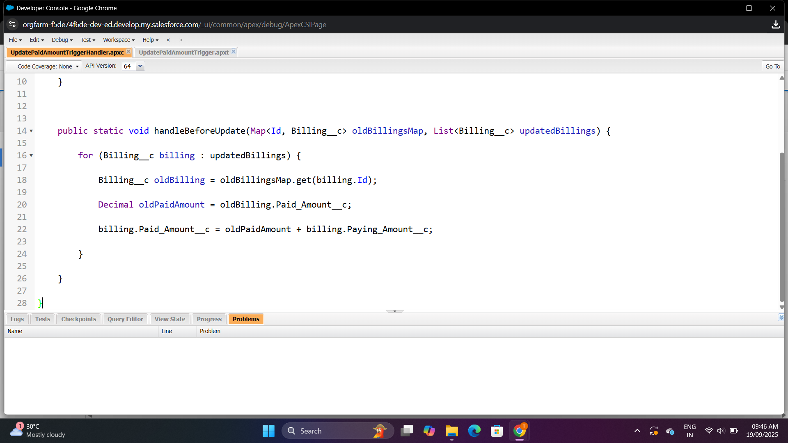

**Advantages**

1. **Centralized Data Management** – Customer details, sales records, and inventory are maintained in one platform, reducing duplication and errors.
2. **Real-Time Inventory Tracking** – Provides accurate updates on precious metals, stones, and finished jewelry, ensuring stock transparency.
3. **Enhanced Customer Engagement** – Captures customer preferences, purchase history, and special occasions, enabling personalized marketing and loyalty programs.

**Disadvantages**

1. **High Implementation Cost** – Initial setup, customization, and Salesforce licensing can be expensive, especially for small jewellers
2. **Training Requirements** – Staff may need dedicated training to effectively use the system, which could take time and resources.
3. **Customization Complexity** – Adapting Salesforce to meet highly specific jewelry business needs may require technical expertise and ongoing support.

**Conclusion:**

The Jewel Management CRM built on Salesforce provides a modern, efficient, and scalable solution to address the unique challenges of the jewelry industry. By integrating sales, customer relationship management, inventory control, and analytics into a single platform, it simplifies operations and enables jewelers to focus on delivering personalized experiences to their customers.

**Apex Coding:**

**UpdatePaidAmountTrigger.apxt:**

trigger UpdatePaidAmountTrigger on Billing__c (before insert, before update) {

if (Trigger.isInsert) {

UpdatePaidAmountTriggerHandler.handleBeforeInsert(Trigger.new);

} else if (Trigger.isUpdate) {

UpdatePaidAmountTriggerHandler.handleBeforeUpdate(Trigger.oldMap, Trigger.new);

}

}

**UpdatePaidAmountTriggerHandler.apxc:**

public class UpdatePaidAmountTriggerHandler {

public static void handleBeforeInsert(List<Billing__c> newBillings) {

for (Billing__c billing : newBillings) {

billing.Paid_Amount__c = billing.Paying_Amount__c;

}

}

public static void handleBeforeUpdate(Map<Id, Billing__c> oldBillingsMap, List<Billing__c> updatedBillings) {

for (Billing__c billing : updatedBillings) {

Billing__c oldBilling = oldBillingsMap.get(billing.Id);

Decimal oldPaidAmount = oldBilling.Paid_Amount__c;

billing.Paid_Amount__c = oldPaidAmount + billing.Paying_Amount__c;

}

}